Thesis Change Report
If your thesis is found acceptable conditional upon revisions, please list the changes made after the examination below. Upon completion of these changes, designated examiners of your Thesis Examination Board will indicate that all changes have been satisfactorily completed by approving the thesis within Scholarship@Western.
Page(s) | Description of Change
How to Append your Thesis Change Report to your Final Thesis Submission
- While submitting the final version of your thesis, indicate that you will be adding additional files to the thesis in the metadata of the submission.
- When you are satisfied with the rest of your metadata on the page, select Submit
- Upload your change report
Follow the directions provided to upload the completed change report.
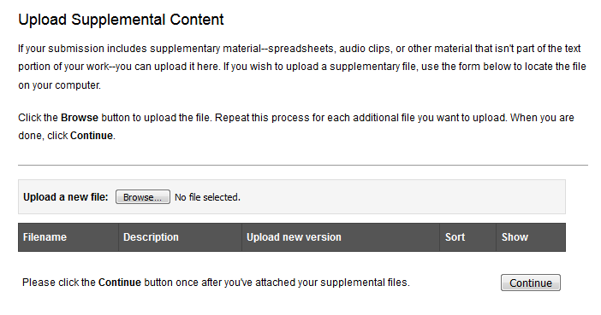
- Select the ‘Continue’ button after your report is listed among your supplemental content.
