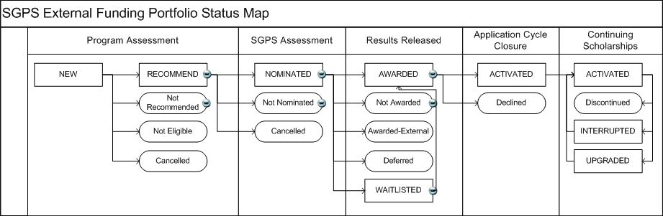

|  |  |  |
| --- | --- | --- |
| **Program Assessment** | **New** | This status indicates the application has been received for a given competition and aid year, however no decisions have been made. |
| **Recommended** | Any application that is assessed by your program committee as worthy of recommendation to SGPS should be noted as RECOMMEND. This status indicates to SGPS that an application will be forwarded to SGPS for further assessment. |
| **Not Recommended** | Any application that is assessed by your program committee but deemed as not recommended for SGPS selection committee assessment should be noted as NOTRECOM. |
| **Not Eligible** | Any application that does not meet the basic eligibility requirements for a given competition and will not progress to the program assessment stage should be assigned a value of NOTELIG. |
| **Cancelled** | Any application that must be removed from circulation for administrative reasons/errors must be applied a status of CANCELED. Applications, once submitted, cannot be removed and may only be placed into a status of CANCELED. |
| **SGPS Assessment** | **Nominated** | This status indicates a student was put forward to an SGPS selection committee and was forwarded to the agency. |
| **Not Nominated** | This status indicates a student was put forward to an SGPS selection committee but was not forwarded to the agency. |
| **Cancelled** | Any application that must be removed from circulation for administrative reasons/errors must be applied a status of CANCELED. Applications, once submitted, cannot be removed and may only be placed into a status of CANCELED. |
| **Results Released** | **Awarded** | This status indicates a student has been awarded a specific Award Type within a competition and has yet to activate or decline the award with Western. |
| **Not Awarded** | This status indicates a student has been forwarded to the agency for consideration but was declined an award. |
| **Awarded-External** | This status indicates a student has been awarded a specific Award Type within a competition and is going to hold the award at another institution. |
| **Deferred** | This status indicates a student has been awarded a specific Award Type within a competition and has deferred the award until a later date. |
| **Waitlisted** | This status indicates a student has been forwarded to the agency for assessment but was placed on a wait list until further notice. |
| **Application Cycle Closure** | **Activated** | This status indicates a student has been awarded a specific Award Type within a competition and has activated the award with Western. |
| **Declined** | This status indicates a student has been awarded a specific Award Type within a competition and has declined the award with Western. |
| **Continuing Scholarships** | **Activated** | This status indicates a student has been awarded a specific Award Type within a competition and has activated the award with Western. |
| **Discontinued** | This status indicates a student has been awarded a specific Award Type within a competition, has activated the award with Western but the award was subsequently stopped. |
| **Interrupted** | This status indicates a student has activated a specific Award Type within a competition and payment of that award type has been temporarily interrupted to coincide with a leave of absence. |
| **Upgraded** | This status indicates a student activated an NSERC PGSM or CGSM and has now been upgraded as a result of a transfer from a master's degree into a doctoral program, by either completing their master's degree in less than the maximum duration of their award and proceeding into a doctoral program, or enrolling directly in a doctoral program following completion of their bachelor's degree. |